**Calculator application requirements**

**Contents**

* Business requirements (BR)
* User requirements (UR)
* Functional requirements (FR):

Common functional requirements (CFR)

Detailed functional requirements (DFR)

* Non-functional requirements (NFR)

**Business requirements**

1. It is necessary to develop a calculator without excessive functionality to speed up the work of company employees.

**User requirements**

1. The calculator must have two modes of operation for the user:

– simple mode, allowing you to perform operations of addition, subtraction, multiplication and division of numbers;

– scientific mode, in addition to the simple mode functionality, allowing to perform the operations of squaring a number and extracting the square root of a number.

**Functional requirements**

**Common functional requirements (CFR)**

1. The calculator must provide calculation with positive, negative, integer, fractional numbers.
2. The calculator must operate with the following symbols (see DFR1.4 – DFR1.6):
   1. Digits – «0», «1», «2», «3», «4», «5», «6», «7», «8», «9»;
   2. Arithmetic signs – «+», «-», «*», «/»;
   3. Symbols «,», «(», «)».
3. The calculator must provide data input from the GUI via mouse and keyboard   
   (see DFR1.4 – DFR1.6).
4. The prototype of the application window in the "Simple" mode is shown in Figure 1.

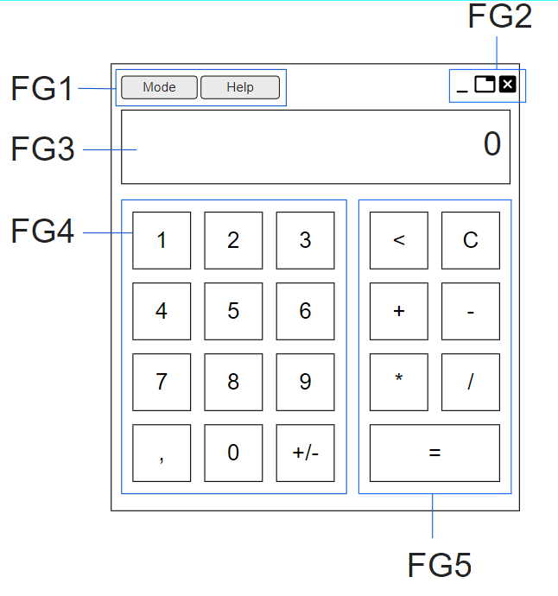

Figure 1

The prototype of the application window in the "Scientific" mode is shown in Figure 2.

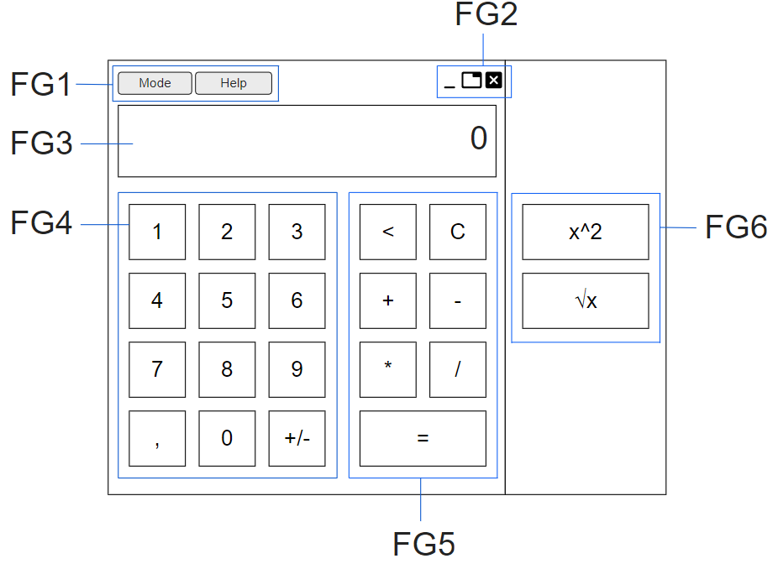

Figure 2

Detailed description of the functionality is presented in the **Detailed functional requirements**.

**Detailed functional requirements (DFR)**

1. Mode selection (functional group FG1)

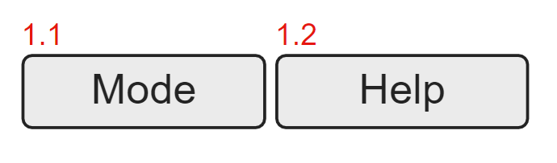

* 1. Button «Mode» – pressing the button displays a menu for selecting the application operating mode with buttons: "Simple", "Scientific" (see UR1);
  2. Button «Simple» – pressing the button turns the application in «Simple» mode and displays the application window as Figure 1 (see CFR4).
  3. Button «Scientific» – pressing the button turns the application in «Scientific» mode and displays the application window as Figure 2 (see CFR4).
  4. Button «Help» – pressing the button displays a menu with buttons «Reference» and «About».

a) Button «References» – pressing the button displays an application description window;

b) Button «About» – pressing the button displays an information about the application (application name, version, release date, copyright);

1. Window control (functional group FG2)

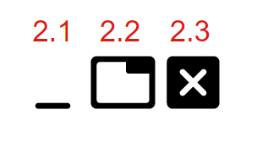

* 1. Button «Minimize» – pressing the button minimizes the application window.
  2. Button «Maximize» – pressing the button maximizes the application window.
  3. Button «Close» – pressing the button Close maximizes the application window.

1. Display field (functional group FG3)
   1. The field displays the entered digits, arithmetic signs, symbols (see CFR2), the final result of the calculation.
   2. The maximum number of displayed characters is 20, when you try to enter more characters, the input stops.
   3. When the application starts, the field displays "0”.

3.4 If invalid characters are entered (see CFR3), an «Error message» window is displayed (see EM1).

3.5 Rounding numbers display 2 digits after decimal point.

4. Digital dial group (functional group FG4):

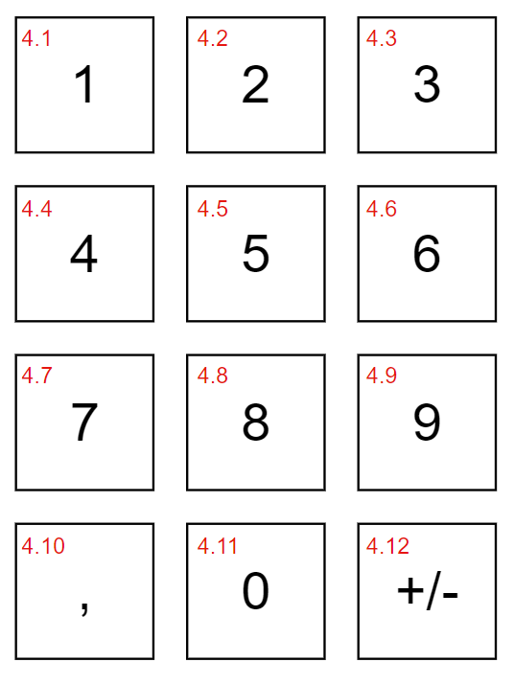

4.1 Button «1» (as keyboard – Numpad button «1») – pressing the button displays digit «1» in Display field.

4.2 Button «2» (as keyboard – Numpad button «2») – pressing the button displays digit «2» in Display field.

4.3 Button «3» (as keyboard – Numpad button «3») – pressing the button displays digit «3» in Display field.

4.4 Button «4» (as keyboard – Numpad button «4») – pressing the button displays digit «4» in Display field.

4.5 Button «5» (as keyboard – Numpad button «5») – pressing the button displays digit «5» in Display field.

4.6 Button «6» (as keyboard – Numpad button «6») – pressing the button displays digit «6» in Display field.

4.7 Button «7» (as keyboard – Numpad button «7») – pressing the button displays digit «7» in Display field.

4.8 Button «8» (as keyboard – Numpad button «8») – pressing the button displays digit «8» in Display field.

4.9 Button «9» (as keyboard – Numpad button «9») – pressing the button displays digit «9» in Display field.

4.10 Button «,» (as keyboard – Numpad button «.») – pressing the button separates the integer part of number from the fractional part and displays symbol «,» in Display field.

4.11 Button «0» (as keyboard – Numpad button «0») – pressing the button displays digit «0» in Display field.

4.12 Button «+/-» – pressing the button reverses the sign of the number in the Display field; if the number becomes negative, the “-” symbol is displayed in the Display field in the cell to the left of the first digit of the number.

5. Group of operations and symbols “Simple” (functional group FG5):

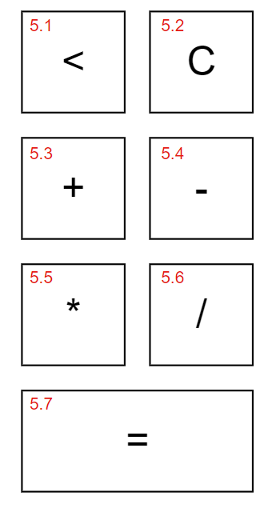

5.1 Button «<» (as keyboard – Numpad button «2») – pressing the button removes the digit from the rightmost cell from the number in the Display field, the remaining digits/symbols are shifted to the right.

5.2 Button «С» – pressing the button removes all numbers and symbols from the in Display field.

5.3 Button «+» (as keyboard – Numpad button «+») – pressing the button adds the number in the Display field and displays the sign «+» in Display field.

5.4 Button «-» (as keyboard – Numpad button «-») – pressing the button subtracts the number in the Display field and displays the sign «-» in Display field.

5.5 Button «*» (as keyboard – Numpad button «*») – pressing the button multiplies the number in the Display field and displays the sign «*» in Display field.

5.6 Button «/» (as keyboard – Numpad button «/») – pressing the button divides the number in the Display field and displays the sign «/» in Display field.

5.7 Button «=» (as keyboard – Numpad button «Enter») – pressing the button displays the result of calculation in Display field.

6. Group of operations and symbols “Scientific” (functional group FG6):

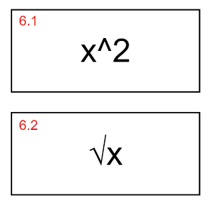

6.1 Button « x2» – pressing the button squaring the number from Display field and displays the result of calculation; when trying to square an expression, an «Error message» window is displayed (see EM1).

6.2 Button «√x» – pressing the button calculating the square root of the number from the Display field and displays the result of calculation; when trying to square root an expression, an «Error message» window is displayed (see EM1).

7. Error message (EM)

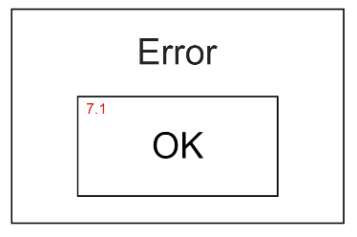

7.1 Button «ОК» – pressing the button closes the Error message window.

**Non-Functional requirements (NFR)**

1. The application must be desktop and work on Windows 8/10 32/64 bit.
2. The time for calculating the result should not exceed 5 ms.
3. The number of concurrent users of the application is 1.
4. The application must have a graphical user interface (see CFR5).
5. The application must be performed in English.
6. The application must use Arial font, font size – 12, font color – black.
7. Final design of application – TBD.